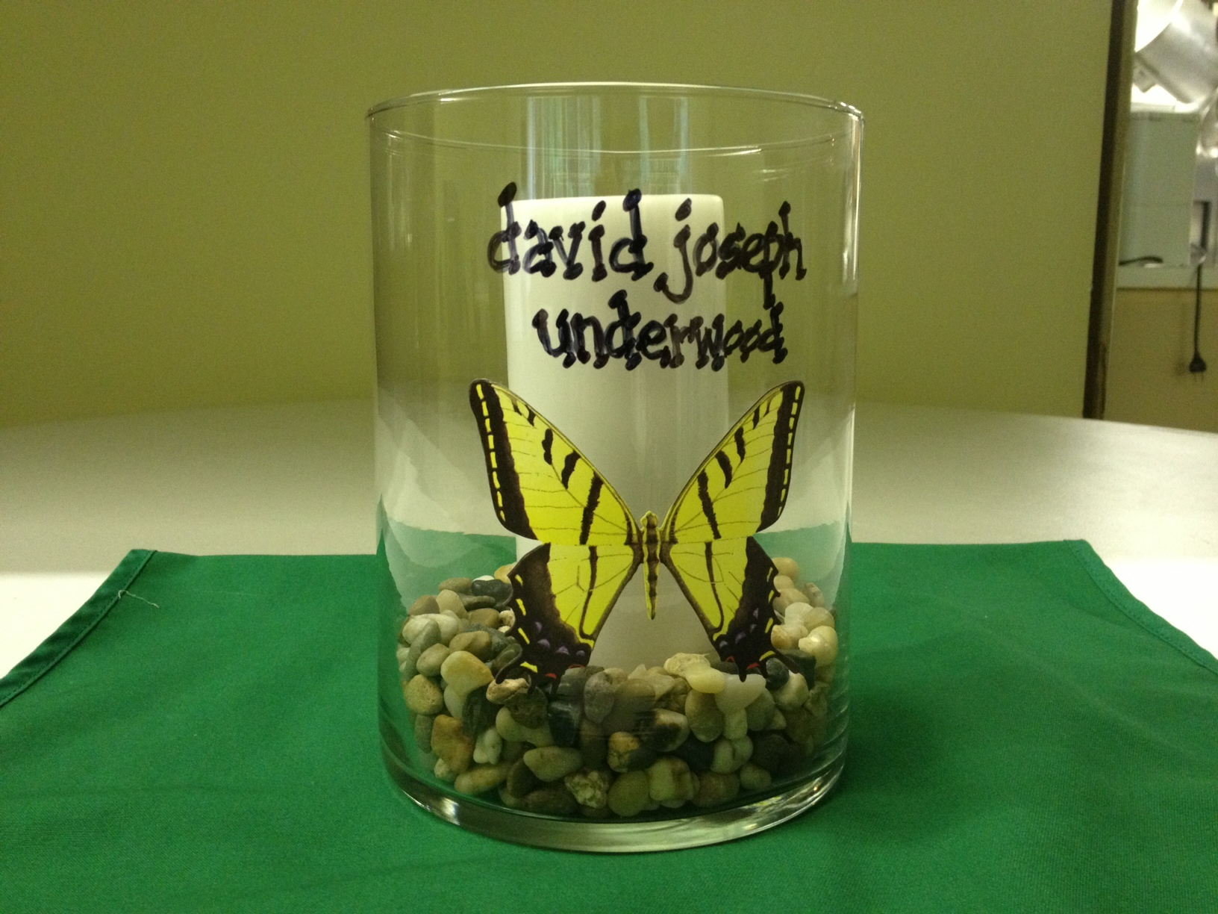  Centerpiece (A) with child’s name  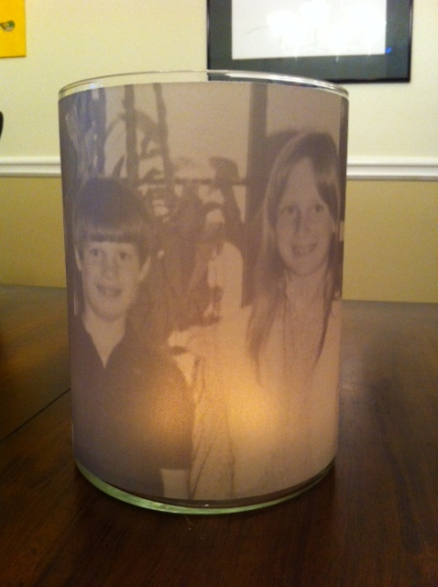 | Atlanta (Tucker) Chapter  33rd Annual Candlelight Remembrance Service  Saturday, December 7, 2013  Centerpieces and Poinsettias for Sale  Deadline to Order in November 15th  Sponsor a Centerpiece or Poinsettia  "In Memory of Your Child/Sibling/Grandchild"  We will display a sign “In Memory of Your Child/Sibling/Grandchild” next to each sponsored item.  After the reception, you can take the centerpiece or flowers home with you as a special remembrance. If you cannot attend the candlelight service, your centerpiece or poinsettia will be donated to a newly-bereaved family to take home after the reception.  The cost of a Centerpiece or Poinsettia is $30. Please consider adding an additional contribution to this fee, to help cover speaker and other Candlelight Service costs. The net proceeds from this fundraiser will help support our annual candlelight remembrance service.
Centerpiece (B) with child’s photo

Your Child’s Name (Full Name as you would like it to read on the Memory Card)

____________________________________________________________________________________________________

Card will read: Sponsored “In Memory of ________________________________________________________”

I want to sponsor a: _____Centerpiece (A) Name _______ Centerpiece (B) Photo _____ Poinsettia

Please check: _____ $30 (Centerpiece/Poinsettia) $_____ Additional contribution to go toward the candlelight service

Please make your check payable to: “The Compassionate Friends” and mail, along with completed form, to:
The Compassionate Friends, c/o Jayne Newton, 808 Brentway Court, Lilburn, GA 30047

Please include an original photo of your child or email the photo in high resolution to Jayne@tcfatlanta.org

